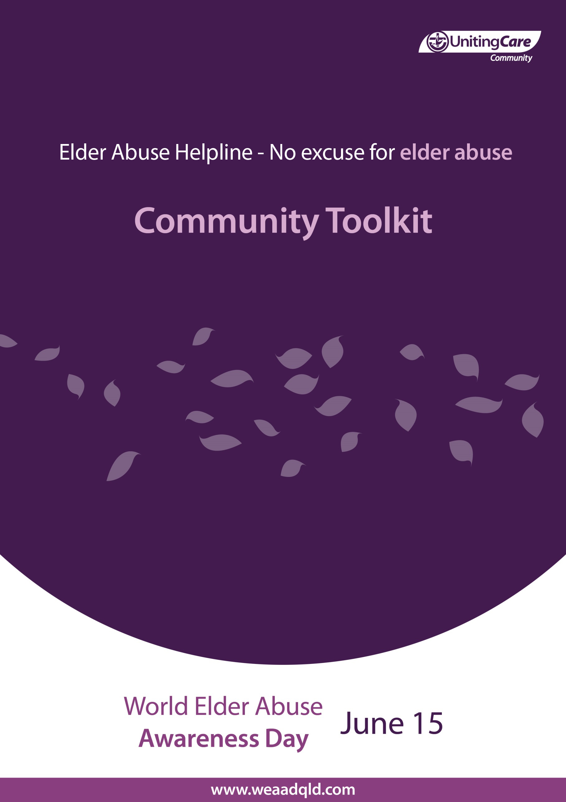
Table of contents

WEAAD Information Sheet 3
Call to Action Poster 4
Web Banners 5
Your Event Poster Template 6
WEAAD Event Ideas 7
Photo Gallery 8
About EAPU 9

World Elder Abuse Awareness Day

15th of June
Public Call-To-Action

Celebrate World Elder Abuse Awareness Day.

Show the world you care about ending elder abuse and neglect by wearing purple and hosting your own awareness raising event during the month of June.

Check out www.weaadqld.com for some suggestions to help you get started.
World Elder Abuse Awareness Day 15th June

JUNE 15 each year is the day designated by the United Nations as the international day of action when the whole world voices its opposition to the abuse of older people. WEAAD is represented by the colour purple – which denotes wisdom, dignity, independence and creativity.
During the week ending the 15th June we are calling for all communities across Queensland, to join the rest of the world in ‘going purple’ for WEAAD. The week leading up to the 15th June is a time when individuals and organisations can come together to raise awareness of elder abuse and to celebrate human rights.
Keep an eye out for purple-themed events in your community in June. Or why not create your own purple-themed event to raise awareness of WEAAD?

What is happening in your community? What can you do? How about having a purple-themed picnic with your family on a Sunday during June? Or wear something purple on the day or during that week and tell people why. Share your event on the Department of Communities website. Put up a poster or have a purple morning tea at your workplace. Remember;

This is not a Fund Raiser....it’s an Awareness Raiser

Out of purple ideas? Check out http://www.weaadqld.com for some suggestions, web links and toolkits to help you get started. Send us your suggestions and we will put them up on the website – if you have one please email us at mailto:eapu@uccommunity.org.au. Don’t forget to share your photos with us. We would love to add them to the photo gallery.

No effort is too small to be a part of this awareness-raising campaign visit www.weaadqld.com to get started.

Web/Email banner (long)
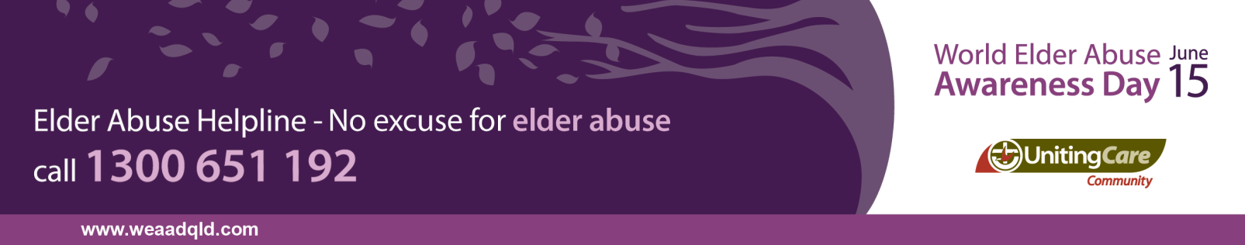

Web/Email banner (short)
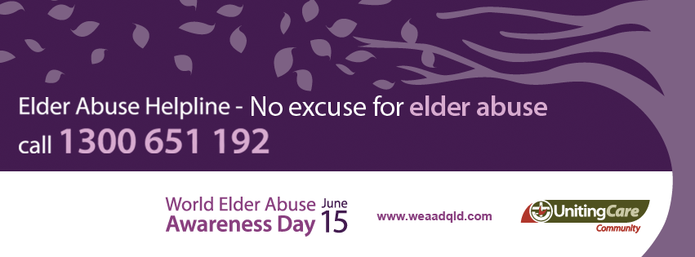
World Elder Abuse Awareness Day
15th of June
Your Event Title
Your Event Date & Time
Your Event Location

WEAAD Event Ideas
Here are some ideas for what you or your organisation can do for WEAAD:
- Organise and promote a purple themed awareness raising walk.
- Organise or promote a purple themed picnic or sausage sizzle in your park
- Invite a guest speaker to discuss the issue of elder abuse.
- Wear purple to work during the week leading up to the 15th of June.
- Use purple lighting in your community to highlight the issue of elder abuse.
- Create an awareness display in your workplace, school, council, library or shopping centre.
- Use purple balloons at a purple themed morning tea at your workplace.
- Use social networking such as Facebook and Twitter – change your profile picture to purple.
- Include the WEAAD logo and information on your email signature during the week leading up to June 15th.

For more ideas and resources visit the WEAAD website – www.weaadqld.com

WEAAD Photo Gallery
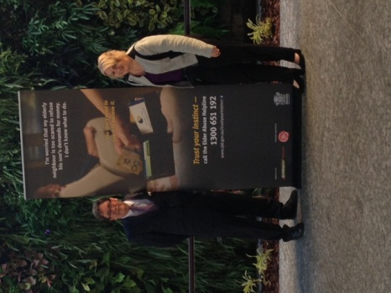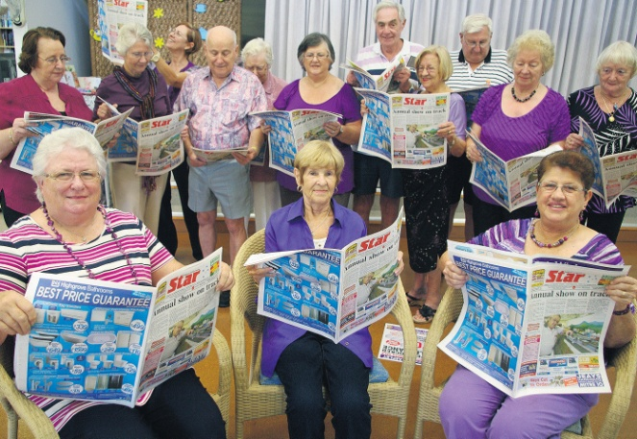
Flash mob – WEAAD 2013
Les at WEAD Expo 2015

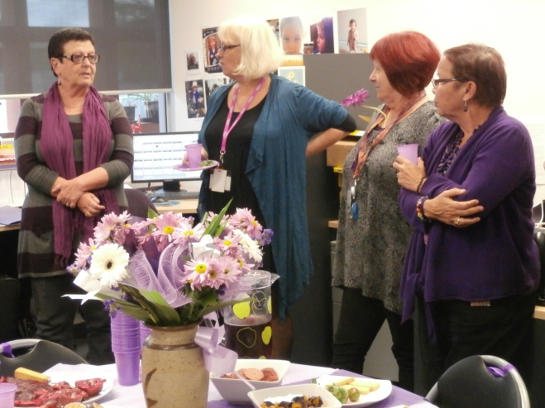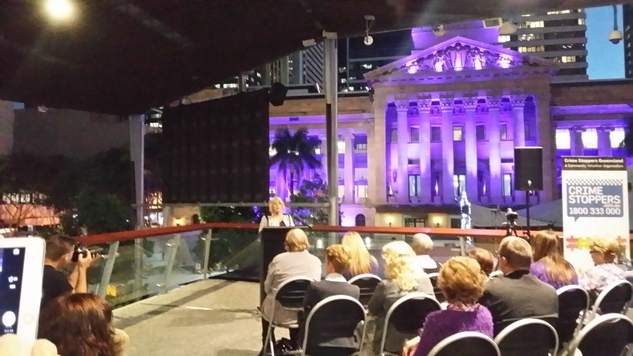
Expo in King George Square – WEAAD 2015
EAPU afternoon tea - WEAAD 2013

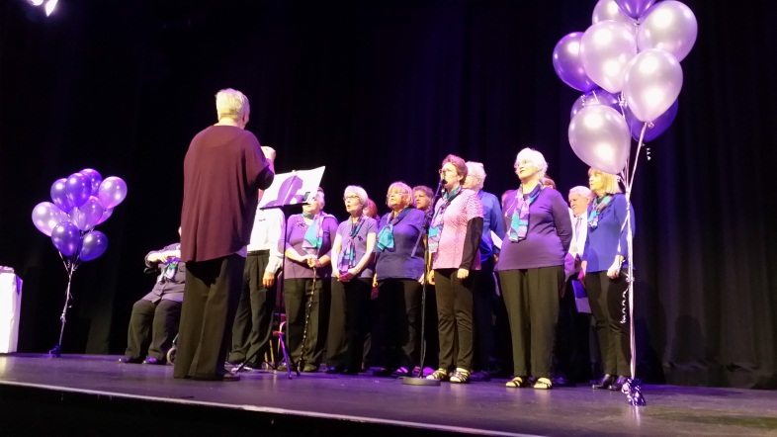
Seniors Choir – WEAAD 2015
Kangaroo Point Cliffs in purple – WEAAD 2014

Share your photos with the EAPU and register your event on the Department of Communities website: https://www.communities.qld.gov.au/communityservices/violence-prevention/trust-your-instinct/elder-abuse/campaign-involvement
About EAPU
The UnitingCare Community’s Elder Abuse Prevention Unit was established in 1998 and is funded by the Queensland government. It is a state-wide service that provides a number of services around the state:
- A helpline that operates Monday to Friday 9am to 5pm.
Helpline operators can provide information, support and referral to anyone who is experiencing elder abuse or anyone who is concerned about an older person being abused. Callers may remain anonymous. All calls are confidential.
- Free training and community education sessions.
Community education is targeted at social and community groups. It is informal and covers rights and strategies to minimise risk of becoming a victim of elder abuse. Training is more in-depth and aimed at workers and volunteers who support older people who may be vulnerable to elder abuse and mistreatment.
- Rural and remote worker Peer Support Network.
The Peer Support Network is an initiative that supports rural and remote workers to access training and expertise via webinars and multimedia, that they would otherwise not be able to access due to geographic limitations.
- Reports on elder abuse and mistreatment in Queensland.
The EAPU produces resources that are used to raise awareness of elder abuse and help people maintain their rights and freedom. These can include statistical reports, such as Annual reports and information/fact sheets and brochures. The EAPU also provides submissions into government policy and enquiries into older people to ensure that older people experiencing abuse or are vulnerable to abuse have their voice heard.

If you would like to book a session or learn more about the EAPU you may visit the website: http://www.eapu.com.au/, call the helpline on 1300 651 192 or email: eapu@uccommunity.org.au.

