Elder Abuse Prevention Unit

Risk Factors
A risk factor is something that may make someone more susceptible to experiencing elder abuse. The causes of elder abuse are varied, complex and often concealed. However, data and anecdotal evidence suggests that certain risk factors are related to abuse, and that the existence of several risk factors places a person at a significantly higher risk of abuse. Key risk factors include carer stress, dependency (e.g. for decision making, ongoing care and/or accommodation), family conflict, isolation, psychological problems and addictive behaviours or substance abuse.
Carer Stress
Caring for a person who is frail or who has special needs is stressful. In many cases, other contributory factors are also present and place additional stress on the carer and trigger the abuse. Here are some examples:
- Financial difficulties
- Lack of respite care (having a break)
- Inadequate support to give high quality care
- Lack of recognition of carer role
- Physical and/ or emotional stress of being a carer affects a person’s health and well-being
- Caring for multiple people simultaneously
- Unfamiliarity with the caring role and its responsibilities.

Dependency
Older people are at risk of abuse from people with whom they live and share a relationship of dependency. This dependency may be due to physical impairments such as physical frailty, disability. Alternatively it may be because of a cognitive impairment such as dementia. These impairments may hinder the person leaving the abusive situation or reporting the situation.
Family violence
Abuse can be a continuation of spousal domestic violence that re-emerges as abuse in the caring situation. Similarly, a child who was previously abused may now be a primary carer and repeat the cycle of abuse to a dependent parent or child. In some families violence is considered the normal reaction to stress, and it may continue from generation to generation. People are also at risk when two or more generations live together and intergenerational conflict exists. In cross-cultural situations where two or more generations hold different cultural values or roles, tension and conflict can place dependent people at risk of abuse.
Isolation
An older person may be isolated and lack social contacts or support. If an older person lacks supportive family members, it can be difficult to arrange what they

need to regain to safety. Sometimes a perpetrator may make it more difficult for a person to keep/ form connections by controlling who sees them and removing phones or other forms of contact. Bereavement of a loved one and feelings of grief can also cause someone to become more isolated.
Mental health
In some cases the mental health of the perpetrator is a major contributory factor to the abuse. Abuse may occur when either party has:
- A period of mental illness
- A history of mental problems
- Difficulty in controlling anger and/or frustration
- Low self-esteem or feelings of low self-worth

Drug, Alcohol and Gambling
Where the carer or a family member has a dependency on drugs, either prescription or illicit, alcohol or a gambling problem, an older person can be considered to be at risk of abuse.

Contact
If you would like to talk to someone about yourself or someone you are concerned about, you can talk to someone confidentially on the Elder Abuse Helpline:
Phone: 1300 192 651
Interstate callers: (07) 3867 2525
Web enquiry:
www.eapu.com.au/contact-us

EA Campaign Launch
Department of Communities, Disability Services & Seniors

Each year the QLD Government oversees a statewide elder abuse awareness and prevention campaign. It usually launches in June to coincide with World Elder Abuse Awareness Day and lasts several months. Here was the Department’s message about the campaign focus this year:

We know the issue is wide-spread and under-reported. We also know there are barriers that prevent older people from reaching out for help themselves, and that’s why it’s up to us to help them to access support when they need it.
Raising awareness of and preventing elder abuse remains our priority. This year’s campaign ‘Elder abuse happens. Know the signs – make it stop’ highlights the most common signs of elder abuse, and encourages Queenslanders to call the helpline if they suspect an older person in their life is being abused and needs help.

The campaign page has information about how to ‘start a conversation about elder abuse’, which may be a helpful tool for supportive family members that you work with. It also contains loads of resources, such as videos, fact sheets, social media kits and posters.

Many people have requested new campaign brochures and more of the ‘wallet sized’ helpcards, which were produced in previous years. These are both being printed this year and should be ready towards late October.
Visit: https://www.communities.qld.gov.au/campaign/know-the-signs
New Financial Protection Services
Free independent financial advice for seniors
If you weren’t yet aware, in May the Minister for Seniors Coralee O’Rourke launched the new ‘financial protection services’ in 10 communities across QLD. The service offers free independent financial advice to seniors with the aim to prevent finanacial abuse or other financial/ legal issues.
The locations where this service are being offerred are: Brisbane, Toowoomba, Hervey Bay, Townsville, Cairns, Gold Coast, Sunshine Coast, Mackay, Rockhampton and Gladstone. These are the current locations where Seniors Legal and Elder Abuse Support Services currently operate.
You can view more information and contact details for the new services here. you can also view the media release here.

Communities of Practice – OPAN
OPAN – Older Persons Advocacy Network
Would you like to join a Community of Practice? OPAN has just begun the launch of a community of practice for Elder Abuse Advocates to learn, share, support, create, problem solve and make new connections, for the purpose of improving the quality, effectiveness and consistency of everyday practice.
The group has just had its first meeting and new members are welcome to join. The group meets monthly via teleconference and sets its own agenda. Meetups usually last about 1 ½ hours.
If you think this might be a good fit for you or a colleague, all someone needs to do to join is make contact with:
Jennie Burrows, Seniors Project Officer, OPAN.
e. jennie.burrows@opan.com.au
Required info includes contact details and answers to the following:
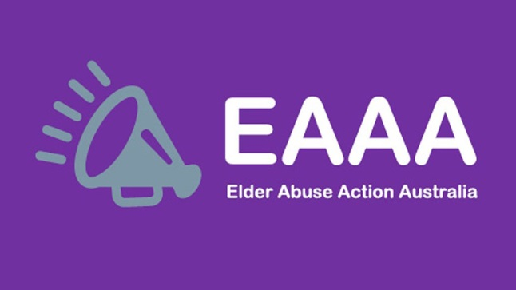
- Do you have access to video-conferencing?
- Are you a practitioner working with older people experiencing abuse?
The next meeting will take place in late October.

Elder Abuse Action Australia
EAAA– A national voice to end elder abuse
In 2018 the Commonwealth Attorney-General’s Department funded the EAAA to fill the need for a national approach to end elder abuse.
To read the full aims, mission and activities of the EAAA you can visit the website. However, broadly the EAAA is seeking to become a national voice for action (prevention and responses) that eliminates elder abuse. Its initial goal has been to establish a ‘knowledge hub’ that will act as an online gateway to elder abuse resources for families, professionals etc.
During the National Elder Abuse Conference 2019 (#NEAC2019), the EAAA board actively encouraged people to join the EAAA as a member and contribute to its direction and voice.
You can sign up to EAAA newsletters and/or become a member by visiting the site here!

NEAC 2019 Wrap-up

Conference resources now available #NEAC2019
Congratulations to ADA Australia and Caxton Legal for successfully executing an exciting and innovative National Elder Abuse Conference in July 2019. If you were not yet aware, the conference presentations were recorded as podcasts and have been made available in the resources section of the main conference website (click here). So if you weren't able to make it, you can still go and check out the world class presenters from around the globe!
For those just wanting to get a sense of the themes that emerged from the event, the conference surveys completed by delegates told all. Delegates responded to the surveys with a resolute commitment to do all they could in their own communities to address elder abuse. CALLS FOR ACTION were focused on the following themes:
- Human rights – identifying ways to apply a rights-based lens to all services which support older Australians
- Criminalisation of elder abuse – you want to engage in ongoing discussion about the need for discrete laws which criminalise the abuse of older Australians
- Awareness raising – there is a need for further education of older people, their families and friends, industry and the community about elder abuse, how to identify it and where to get supports
- Prevention – research should be focussed on increasing our understanding about what prevention activities will work and then we need to adopt a collaborative approach towards implementing those activities
- Ageism – joining together to combat ageism in all the ways it exists in Australian society
- Older person led initiatives – older Australians should be empowered to take the lead on addressing elder abuse
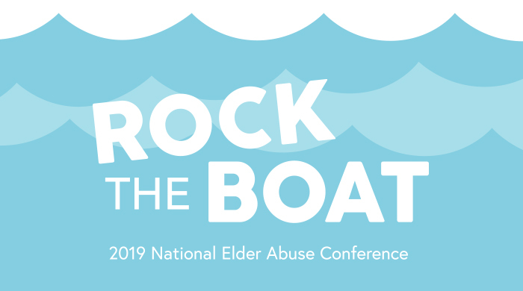

Elder Abuse in the Media: June-Sept.

June:
June 4: Elder abuse: Carer charged over alleged neglect of 77-year-old Queensland woman
7 News
June 4: Can a killer inherit the estate of their victim?
ABC
June 4: Federal funding to reduce elder abuse in Peel
Mandurah Coast Time
June 6: Elderly LGBTQI+ aged care residents say they’re being forced ‘back into the closet’
SBS
June 6: NOT OKAY: Cops intervene to stop elder abuse
Queensland Times
June 6: Hairdressers to help spot signs of elder abuse
Mirage News
June 9: Gold Coast has highest rate of elder abuse in Qld
News.com.au
June 11: Gold Coast elderly abuse some of worst in Qld, according to Elder Abuse Prevention Unit
Gold Coast Bulletin
June 11: Shocking figures reveal elder abuse crisis
Fraser Coast Chronicle
June 14: Elder abuse is the perfect crime: if we don’t address it, you could be a victim too
ABC
June 15: WA Government, banks join forces in crackdown on financial abuse of elderly people
ABC
June 16: Voluntary euthanasia to begin in Victoria as assisted dying laws take effect this week
ABC
June 20: US expert calls out Australia on elder abuse
Australian Ageing Agenda
June 23: Number of Queensland elder abuse cases continues to soar
Courier Mail
June 24: Elder abuse by carer caught on camera
The West Australian
June 26: Risks flagged amid lending policy changes
The Adviser
June 27: Ombudsman finds State Trustees failed Victoria’s most vulnerable
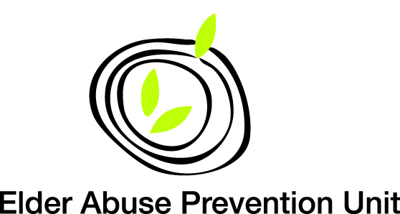
Sydney Morning Herald

Elder Abuse in the Media: June-Sept.

July:
July 5: Health professionals voice disappointment over lack of bush commission hearings
ABC
July 6: ‘He could check everything I bought’: This is what financial abuse looks like
ABC
July 12: Aged care royal commission told of need to install surveillance to stop elder abuse
ABC
July 15: More complaints to AFCA than expected
Finance
July 22: Older Australians abused over sexuality and money, conference hears
Sydney Morning Herald
July 23: Banks urged to protect senior Australians from digital scams
ABC
July 25: Webcams in nursing home rooms may deter elder abuse – but are they ethical?
The Conversation

August:
Aug 7: Anna Bligh calls for a shake-up to elderly financial abuse laws
Now to Love
Aug 7: Banks in fresh push to block inheritance greed
Sydney Morning Herald
Aug 31: ACT looks to make elder abuse a crime
The Canberra Times

September:
Sept 2: Elder abuse help on offer at Dementia Café
Bundaberg Now
Sept 4: Physical abuse, use of chemical restraints among complaints to aged care watchdog in Tasmania
ABC
Sept 11: Gold Coast aged care home that abruptly shut down also subject of abuse claims
The Guardian
Sept 16: Australian bank tackles vulnerable client issue
International Adviser

Media Statements:
June 11: State Budget focus on improved protections for Queensland seniors
Queensland Government
June 13: Elderly suffering due to Government’s lack of proper action
Office of the Public Advocate (Qld)

Research:
June: Elder Abuse: Key issues and emerging evidence
Australian Institute of Family Studies

